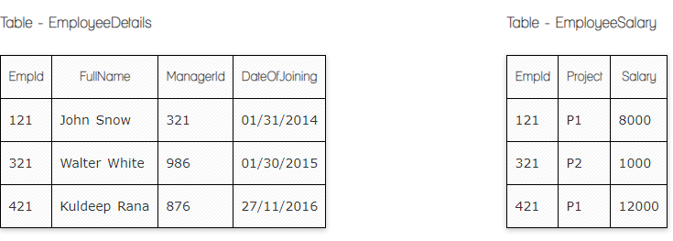

**Write a SQL query to fetch the count of employees working in project 'P1'.**

**Your Answer:**

**Select count (Empid)**

**From EmployeeSalary**

**where project=”P1”;**

**Write a SQL query to fetch employee names having salary greater than or equal to 5000 and less than or equal 10000.**

**Your Answer:**

**Select EmployeeDetails FullName**

**From EmployeeSalary**

**Innerjoin EmployeeDetails**

**On EmployeeSalary.EmpId=EmployeeDetails.EmpId**

**Where salary between 5000 and 10000;**

**Write a query to fetch employee names and salary records. Return employee details even if the salary record is not present for the employee.**

**Your Answer:**

**Select EmployeeDetails.FullName, EmployeeSalary.Salary from EmployeeDetails**

**Left Join EmployeeSalary**

**On EmployeeSalary.EmpId = EmployeeDetails.EmpId;**

**Now take these two tables:**

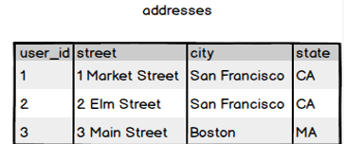

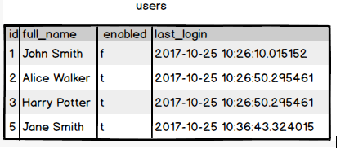

**Write a SQL query to fetch all users full_name from San Francisco.**

**Your Answer:**

**Select full_name from addresses a**

**Inner join users on address.user_id = user.id**

**Where city like ‘%San Francisco%’;**

**Write a SQL query to fetch user full_name who is equal to user_id from Boston (find user_id value in sub_query)**

**Your Answer:**

**Select full_name from users**

**Where id in (Select user_id from addresses**

**Where city = ‘Boston’)**